

School-Age Programming Application Form

Date: _____________________

This application form is for enrolling your child in the school-age program during the 2024-2025 school year. During this period, a program coordinator will ask you about activities your child completes and track his or her attendance. The coordinator will also collect assessment data from your child(ren)’s school periodically. We collect the information to document services offered to your child and monitor program progress. If you do not wish for your child(ren)’s information to be used as part of Save the Children’s annual evaluation of its programming, please fill out the separate Data Decline form.

To enroll in school-age programming, please fill out the application below and return it to your child(ren)’s teacher by ___________. We assure any information identifying you or your child(ren) will remain confidential. If you have any further questions about the research, please contact Beth Eagleton at beagleton@savechildren.org. Sharing this information is voluntary. There is no penalty for choosing not to share the information and should you decline it will not impact your child’s participation in school-age programs. Please also feel free to contact Beth if you seek to withdraw consent at a future date.

We know that even though race and ethnicity are things people made up, racism is a real problem that continues to affect some groups more than others. We collect information about the families we serve so we can see how fair we're being to everyone. It's okay if you don't want to tell us about your child's race or ethnicity—it's your choice and has no impact on this application. We only use this information to improve our programs and to show others how we're doing.

Sex | Race/Ethnicity
- Female  - Male | - African American/Black  - American Indian/Alaska Native/First Peoples/Indigenous  - Asian/Asian American  - European American/white  - Latine  - Hispanic  - Middle Eastern/North African  - Native Hawaiian/Pacific Islander  - Multi-Racial  - Other  - Prefer not to answer

School: Northwest Elementary _________________________________________________________________________________________________

Child Name: |  | Current Grade: | Birthday:
Sex: | Race/Ethnicity:
Child Name: |  | Current Grade: | Birthday:
Sex: | Race/Ethnicity:
Child Name: |  | Current Grade: | Birthday:
Sex: | Race/Ethnicity:
Child Name: |  | Current Grade: | Birthday:
Sex: | Race/Ethnicity:

Address:
Parent/Guardian Name:
Phone #: | E-mail:
Parent/Guardian Name:
Phone #: | E-mail:
Preferred form of Communication (circle one):
Phone Text E-mail Virtual Call Other (Please list)

My child has permission to participate in Save the Children’s school-age program.

____________________________________________________________________________________________________________
Parent/Guardian Signature Date

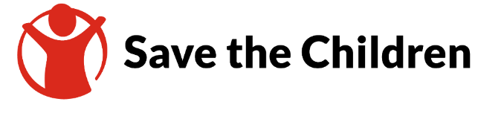
For Program Coordinator to complete:
Child Name: _______________________
State ID #: _________________
Start Date: ___/___/____
2024-2025
Child Information Form

Child Information
Transportation (circle): | Car Rider | Bus Rider

Guardian Information ***This is to be someone OTHER than legal guardians.
In case of emergency, after attempting the above phone number(s) under Parent Information, Save the Children will contact the following additional name(s) of responsible person(s) who you authorized to act on behalf of the parent in the event of an emergency.
Name: _____________________________________________________ Relationship: ____________________________________
Cell Phone Number: __________________________________
Home Address: ______________________________________________ Home Phone: __________________________________
Work Address: _______________________________________________ Work Phone: ___________________________________
Other than who is listed above, who may pick up your child? (Must be 18 years of age or older)
Name: ___________________________________ Relationship: ___________________________ Phone: _______________________
Name: ___________________________________ Relationship: ___________________________ Phone: _______________________
Name: ___________________________________ Relationship: ___________________________ Phone: _______________________
Child Medical Information ***this entire section is required
If my child requires emergency medical care and I cannot be reached, I give my consent to the Save the Children program to obtain the necessary medical care for my child. I agree to pay all costs associated with the emergency medical care that my child receives. I understand that every effort will be made to contact me before and after medical care is provided. I understand that this consent will be in effect as of the date of my signing this form and will continue as long as my child is enrolled in this program.
______________________________________ _____________________________________________ _____________________
Parent/Guardian Name (Print) Signature of Parent/Guardian Date
Physician’s Name: ___________________________________________ Phone: __________________________ (required)
Physician’s Address: ___________________________________________ Hospital of Choice: ___________________________
Health Insurance/Coverage Provider: ___________________________________________ Phone: __________________________

History of Illnesses (Please Check)
This is not applicable to my child – Parent Initial ________
 | Allergies or reactions to medicine, DPT, or insects  Problems with skin rash  Reaction (bumpy or swollen) to TB Skin test  Trouble with eyes or sight  Wears glasses, contacts or protective eye wear  Speech or Hearing problems  Urinary tract infections (Bladder or Kidney)  Frequent ear infections / tubes in ears  Diabetes  Abdominal (stomach) pain  Problems with diarrhea / constipation  History of bed wetting  Eating disorder |  | Hemophiliac (free bleeder)  Frequent headaches  Head Injury  Ever been knocked unconscious  Fainting spells  Ever passed out during or after exercise Ever been dizzy during or after exercise  Seizures / convulsions  Asthma / breathing problems  Lung disease / shortness of breath  Heart disease / heart murmur  Frequent colds / upper respiratory infections  Frequent sore throat
Please provide special instructions concerning any of the above: ___________________________________________________
_________________________________________________________________________________________________________________________
Does your child have any problems not listed above? _______________________________________________________________
_________________________________________________________________________________________________________________________

Allergies and Medications
My child does not have allergies/is not taking any medications – Parent Initial __________
Medications _____________________________  Food _____________________________________  Respiratory ______________________________  Bee/wasp sting: __________________________  Other: ____________________________________ | Please list all medications taken routinely. Use back if necessary.  Med. #1: __________________________ Taken for _________________________  Med. #2: __________________________ Taken for _________________________  Med. #3: __________________________ Taken for _________________________  Med. #4: __________________________ Taken for _________________________  Med. #5: __________________________ Taken for _________________________

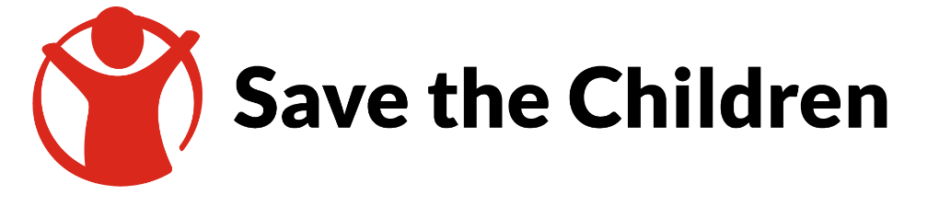

Additional Family Information

Parent/Guardian Name: _________________________________
Parent/Guardian phone number: __________________________

Please list all other children in your home:
Name: ______________________________ Age: ____________
Name: ______________________________ Age: ____________
Name: ______________________________ Age: ____________
Name: ______________________________ Age: ____________
Name: ______________________________ Age: ____________
Are you currently pregnant? YES NO

